Week | Assignment | Using  Kit # | Forms due | Reports  due
1 | - | - | - | -
2 | 1B | 1 | C14, C16, C18, C20 | -
3 | 2A | 2 | C16, C18, C20, C25, C27, C29 | R1, R2
4 | 2B | 3 | C16, C18, C20, C25, C27, C29 | R3
5 | 3B | 4 | C16, C18, C20, C27, C29, C34, C37, C39 | -
6 | 4B | 5 | C16, C18, C20, C27, C29, C37, C39, C45, C47, C49 | -
7 | 5B | 6 | C16, C18, C20, C27, C29, C37, C39, C45, C47, C49 | -
8 | - | 7 | C27 | R4
9 | 6B | 8 | C16, C18, C20, C27, C29, C37, C39, C47, C49, C55, C57, C58 | -
10 | 7B | 9 | C16, C18, C20, C27, C29, C37, C39, C47, C49, C55, C57, C58 | -

Physical & Logical LOC Results

Program 1B
org.greg.drexel.b1.Main.java
- Physical LOC: 109
- Logical LOC: 32

org.greg.drexel.b1.gui.MainFrame.java
- Physical LOC: 296
- Logical LOC: 90

org.greg.drexel.b1.types.FileModeType.java
- Physical LOC: 32
- Logical LOC: 10

org.greg.drexel.b1.io.MyFileReader.java
- Physical LOC: 65
- Logical LOC: 13

org.greg.drexel.b1.io.MyFileWriter.java
- Physical LOC: 64
- Logical LOC: 12

Program 2A
org.greg.drexel.a2.loc.CountingStandard.java (Added from 1B)
- Physical LOC: 109
- Logical LOC: 33 (All 33 LOC added)

org.greg.drexel.a2.loc.LOCCounter.java (Added from 1B)
- Physical LOC: 87
- Logical LOC: 20 (All 20 LOC added)

org.greg.drexel.b1.Main.java (Modified from 1B)
- Physical LOC: 108
- Logical LOC: 41 (1B: 32, so 41-32 = 9 LOC added)

org.greg.drexel.b1.gui.MainFrame.java (Modified from 1B)
- Physical LOC: 174
- Logical LOC: 55 (1B: 90, so 90-55 = 35 LOC deleted)

org.greg.drexel.b1.io.MyFileReader.java (Untouched from 1B)
- Physical LOC: 65
- Logical LOC: 13 (Same LOC from 1B, untouched code)

org.greg.drexel.b1.io.MyFileWriter.java (Modified from 1B)
- Physical LOC: 64
- Logical LOC: 12 (Same LOC from 1B, only modified LOC)

Note: Completely removed org.greg.drexel.b1.types.FileModeType.java from 1B (10 LOC deleted)

Program 2B
org.greg.drexel.b1.Main.java (Modified from 1B)
- Physical LOC: 147
- Logical LOC: 46 (1B: 32, so 46-32 = 14 LOC added)

org.greg.drexel.b1.gui.MainFrame.java (Modified from 1B)
- Physical LOC: 478
- Logical LOC: 148 (1B: 90, so 148-90 = 58 LOC added)

org.greg.drexel.b1.io.MyFileReader.java (Untouched from 1B)
- Physical LOC: 65
- Logical LOC: 13 (Same LOC from 1B, untouched code)

org.greg.drexel.b1.io.MyFileWriter.java (Modified from 1B)
- Physical LOC: 64
- Logical LOC: 11 (1B: 12, so 12-11 = 1 LOC deleted)

org.greg.drexel.b1.types.FileModeType.java
- Physical LOC: 33
- Logical LOC: 11 (1B: 12, 1 LOC added)

org.greg.drexel.b1.types.FileModifyType.java (New in 2B)
- Physical LOC: 35
- Logical LOC: 13 (All 13 lines added, new class)

Program 3B
org.greg.drexel.b1.Main.java (Untouched from 2B)
- Physical LOC: 147
- Logical LOC: 46

org.greg.drexel.b1.gui.MainFrame.java (Modified from 2B)
- Physical LOC: 484
- Logical LOC: 151 (2B: 148, so 151-148 = 3 LOC added)

org.greg.drexel.b1.io.MyFileReader.java (Untouched from 2B)
- Physical LOC: 65
- Logical LOC: 13

org.greg.drexel.b1.io.MyFileWriter.java (Untouched from 2B)
- Physical LOC: 64
- Logical LOC: 11

org.greg.drexel.b1.types.FileModeType.java (Untouched from 2B)
- Physical LOC: 33
- Logical LOC: 11

org.greg.drexel.b1.types.FileModifyType.java (Untouched from 2B)
- Physical LOC: 35
- Logical LOC: 13

Program 4B
org.greg.drexel.b1.Main.java
- Physical LOC: 202
- Logical LOC: 68 (4+8+8+8=28 LOC added, 1 LOC modified, 3+3=6 LOC deleted)

org.greg.drexel.b1.gui.MainFrame.java
- Physical LOC: 511
- Logical LOC: 169 (18 LOC added, 1 LOC modified)

org.greg.drexel.b1.io.MyFileReader.java (Untouched from 3B)
- Physical LOC: 65
- Logical LOC: 13

org.greg.drexel.b1.io.MyFileWriter.java (Untouched from 3B)
- Physical LOC: 64
- Logical LOC: 11

org.greg.drexel.b1.types.FileModeType.java (Untouched from 3B)
- Physical LOC: 33
- Logical LOC: 11

org.greg.drexel.b1.types.FileModifyType.java (Untouched from 3B)
- Physical LOC: 35
- Logical LOC: 13

Program 5B
org.greg.drexel.b1.Main.java
- Physical LOC: 237
- Logical LOC: 80 (12 LOC added, 4 LOC modified)

org.greg.drexel.b1.gui.MainFrame.java
- Physical LOC: 552
- Logical LOC: 185 (20 LOC added, 9 LOC modified, 4 LOC deleted)

org.greg.drexel.b1.io.MyFileReader.java
- Physical LOC: 69
- Logical LOC: 15 (2 LOC added, 4 LOC modified)

org.greg.drexel.b1.io.MyFileWriter.java
- Physical LOC: 86
- Logical LOC: 18 (7 LOC added, 1 LOC modified)

org.greg.drexel.b1.types.FileModeType.java (Untouched from 4B)
- Physical LOC: 33
- Logical LOC: 11

org.greg.drexel.b1.types.FileModifyType.java (Untouched from 4B)
- Physical LOC: 35
- Logical LOC: 13

Program 6B
org.greg.drexel.b1.Main.java
- Physical LOC: 273
- Logical LOC: 104 (24 LOC added)

org.greg.drexel.b1.gui.MainFrame.java
- Physical LOC: 592
- Logical LOC: 208 (23 LOC added)

org.greg.drexel.b1.io.MyFileReader.java (Untouched from 5B)
- Physical LOC: 69
- Logical LOC: 15 (2 LOC added, 4 LOC modified)

org.greg.drexel.b1.io.MyFileWriter.java (Untouched from 5B)
- Physical LOC: 86
- Logical LOC: 18

org.greg.drexel.b1.types.FileModeType.java (Untouched from 5B)
- Physical LOC: 33
- Logical LOC: 11

org.greg.drexel.b1.types.FileModifyType.java (Untouched from 5B)
- Physical LOC: 35
- Logical LOC: 13

org.greg.drexel.b6.regression.RegressionCalc.java (new in 6B)
- Physical LOC: 285
- Logical LOC: 125

Program 7B
org.greg.drexel.b1.Main.java
- Physical LOC: 288
- Logical LOC: 114 (6 LOC modified, 10 LOC added)

org.greg.drexel.b1.gui.MainFrame.java
- Physical LOC: 604
- Logical LOC: 217 (10 LOC modified, 9 LOC added)

org.greg.drexel.b1.io.MyFileReader.java (Untouched from 6B)
- Physical LOC: 69
- Logical LOC: 15 (4 LOC modified, 2 LOC added)

org.greg.drexel.b1.io.MyFileWriter.java
- Physical LOC: 112
- Logical LOC: 26 (1 LOC modified, 8 LOC added)

org.greg.drexel.b1.types.FileModeType.java (Untouched from 6B)
- Physical LOC: 33
- Logical LOC: 11

org.greg.drexel.b1.types.FileModifyType.java (Untouched from 6B)
- Physical LOC: 35
- Logical LOC: 13

org.greg.drexel.b6.regression.RegressionCalc.java
- Physical LOC: 402
- Logical LOC: 177 (8 LOC modified, 52 LOC added, 3 LOC deleted)
Totals
Program 1B
- Physical LOC: 626
- Logical LOC: 157
Program 2A
- Physical LOC: 607
- Logical LOC: 174
Program 2B
- Physical LOC: 822
- Logical LOC: 242
Program 3B
- Physical LOC: 828
- Logical LOC: 245
Program 4B
- Physical LOC: 910
- Logical LOC: 285
Program 5B
- Physical LOC: 1012
- Logical LOC: 324 (41 LOC added, 18 LOC modified, 4 LOC deleted)
Program 6B
- Physical LOC: 1373
- Logical LOC: 494 (170 LOC added)
Program 7B
- Physical LOC: 1543
- Logical LOC: 573 (29 LOC modified, 79 LOC added, 3 LOC deleted)

Note: Assignment 6B was SVN merged into Assignment 7B.
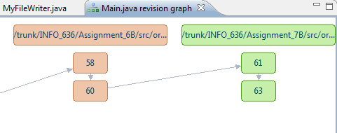
Program 7B Screenshots
Screenshots during testing

Important note: tableA2_70percentConf in RegressionCalc.java only supports 70% prediction intervals using Table A2 in the text. This means the projects made in this application use a 70% prediction interval only. The Excel spreadsheet screenshots also use this same 70% prediction interval.

Program functionality is to be described in the following screenshots. Program 7B adds an additional user-input step for read/write/modify modes to capture the estimated LOC (see Figure 3, 13, and 23).

Regression calculations from Program 2B - Program 5B (Testing Read functionality)

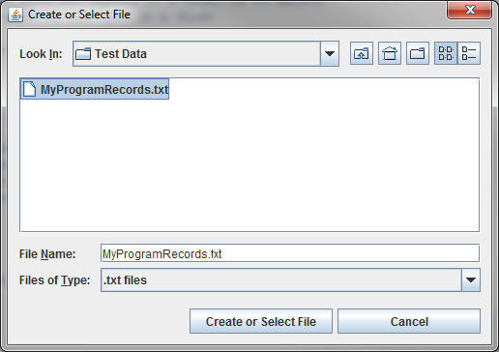
Figure 1. Select text file that has data from previous 2B-5B applications (see Table 1)

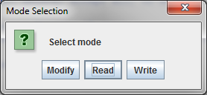
Figure 2. Select Read

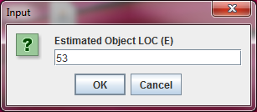
Figure 3. Input estimated LOC as 53

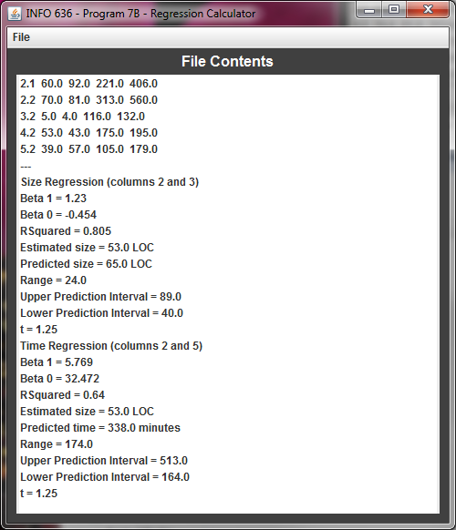
Figure 4. Regression estimates are displayed

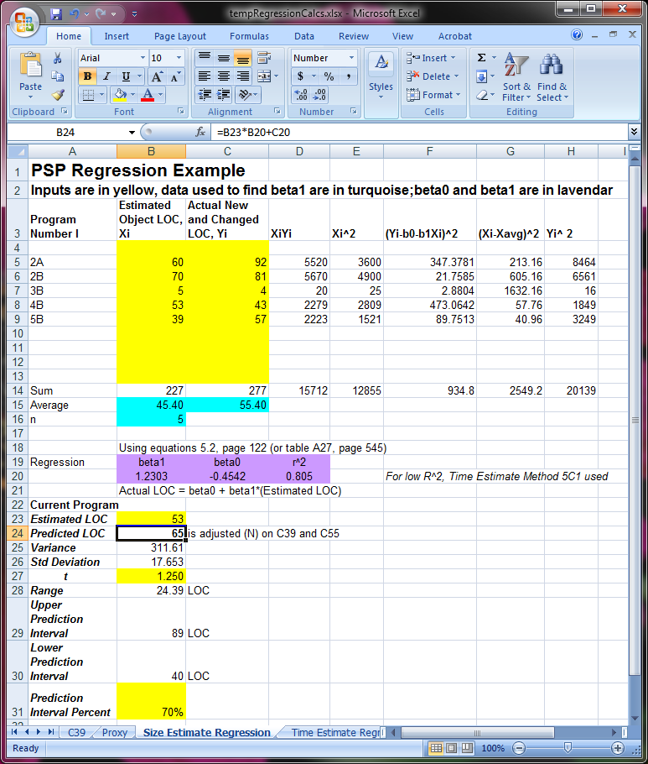
Figure 5. Size estimations from Figure 4 match

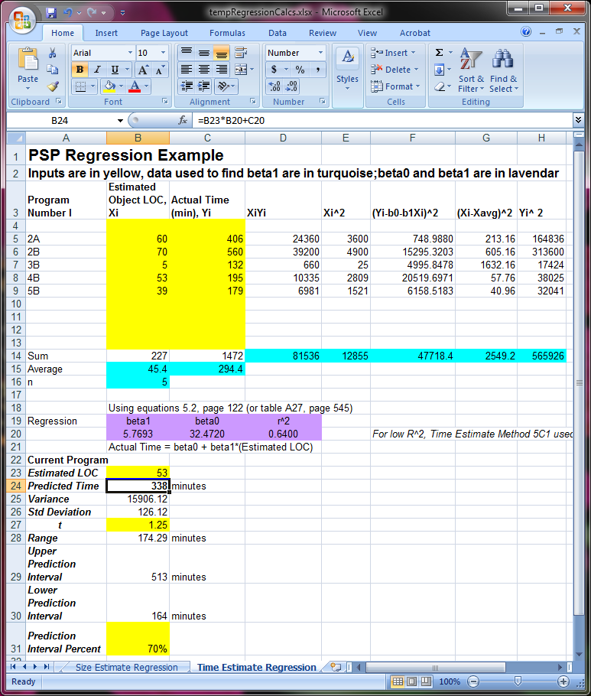
Figure 6. Time estimations from Figure 4 match

Adding Program 6B Data (Testing modify functionality)

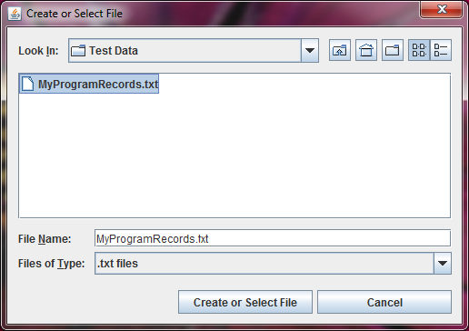
Figure 7. Select same file

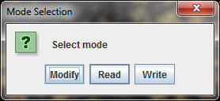
Figure 8. Select modify action

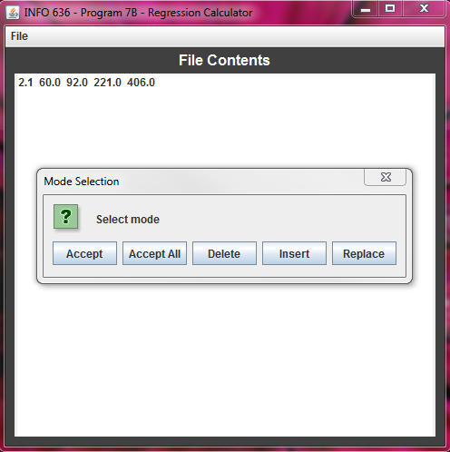
Figure 9. Select Accept option until the last line

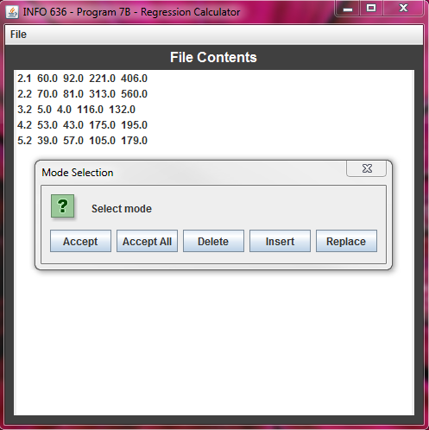
Figure 10. Select Insert option

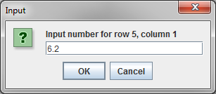
Figure 11. Insert data for Program 6B (see Table 1)

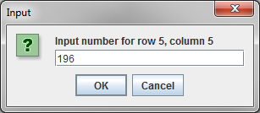
Figure 12. Finish inserting data about Program 6B
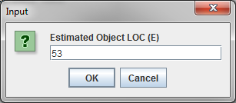
Figure 13. Estimate the same LOC

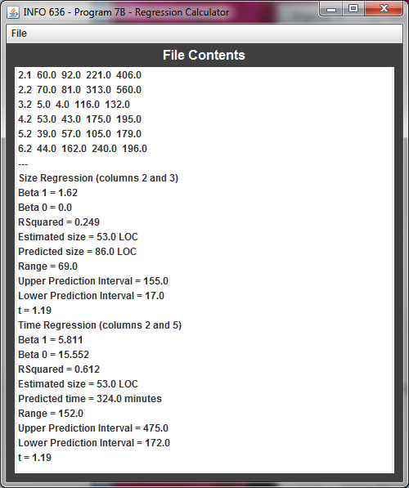
Figure 14. Added program 6B (6.2) information with regression estimates

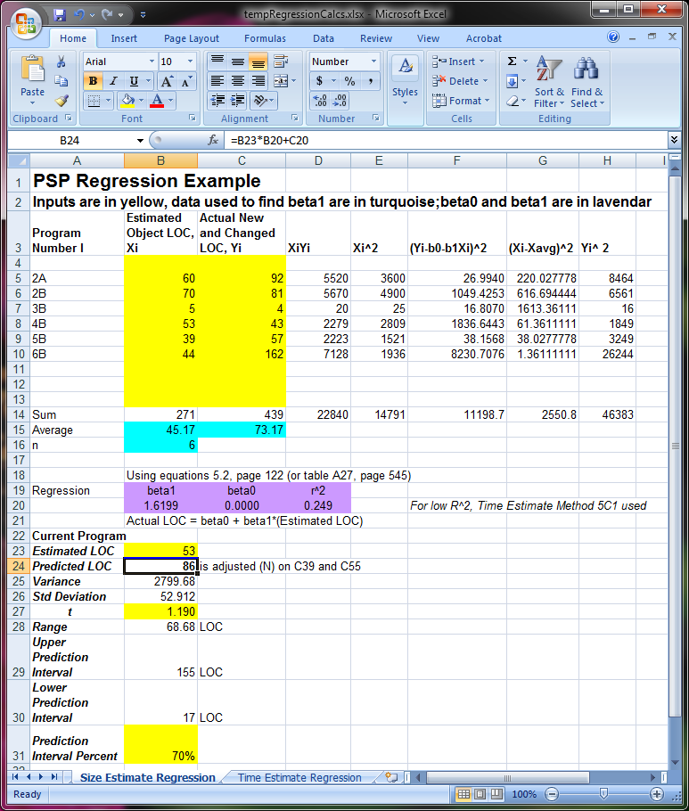
Figure 15. Newly added Program 6B matches spreadsheet for size estimates

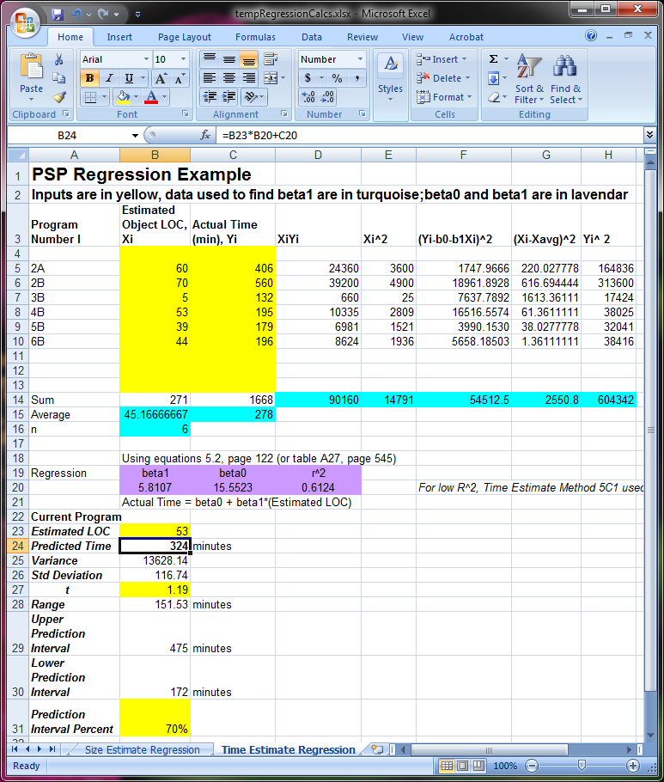
Figure 16. Newly added Program 6B matches spreadsheet for time estimates

Adding data from scratch (testing Write functionality)

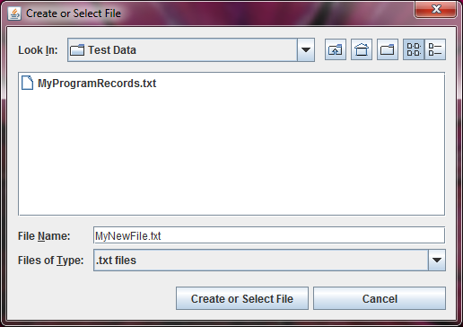
Figure 17. Name a file to write to

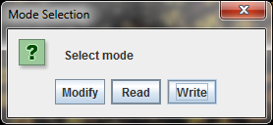
Figure 18. Select write mode

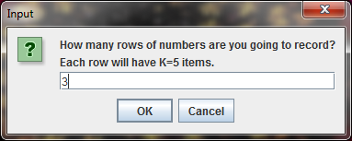
Figure 19. Elect to insert 3 rows (Program 2A, 2B and 3B) of data

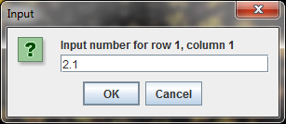
Figure 20. Insert Program 2A's data (see Table 1)

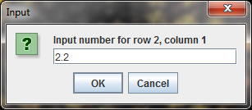
Figure 21. Insert Program 2B's data

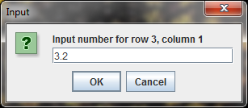
Figure 22. Insert Program 3B's data

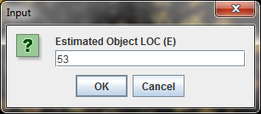
Figure 23. Estimate the same LOC

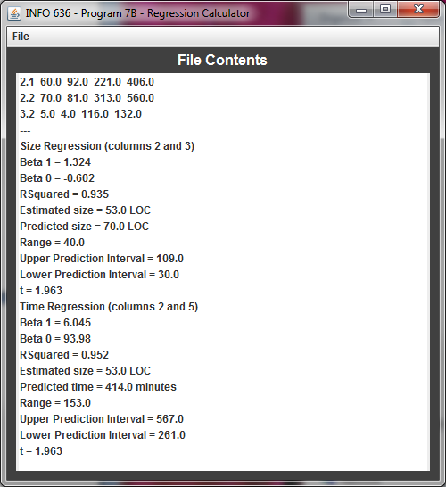
Figure 24. Regression calculations shown

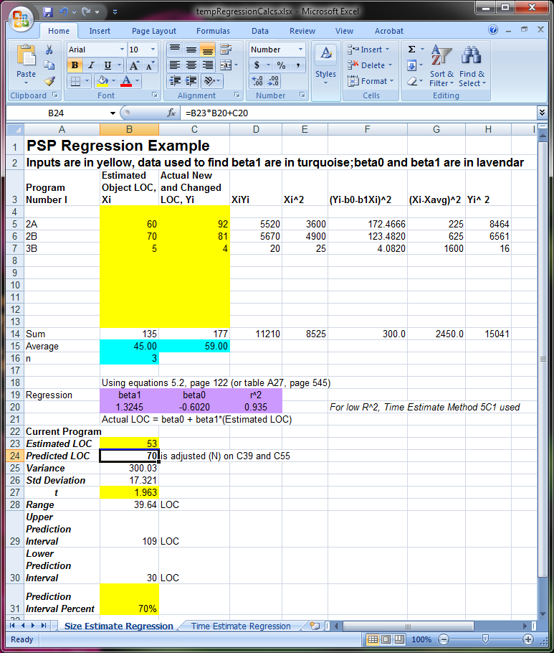
Figure 25. Regression estimates for size match spreadsheet

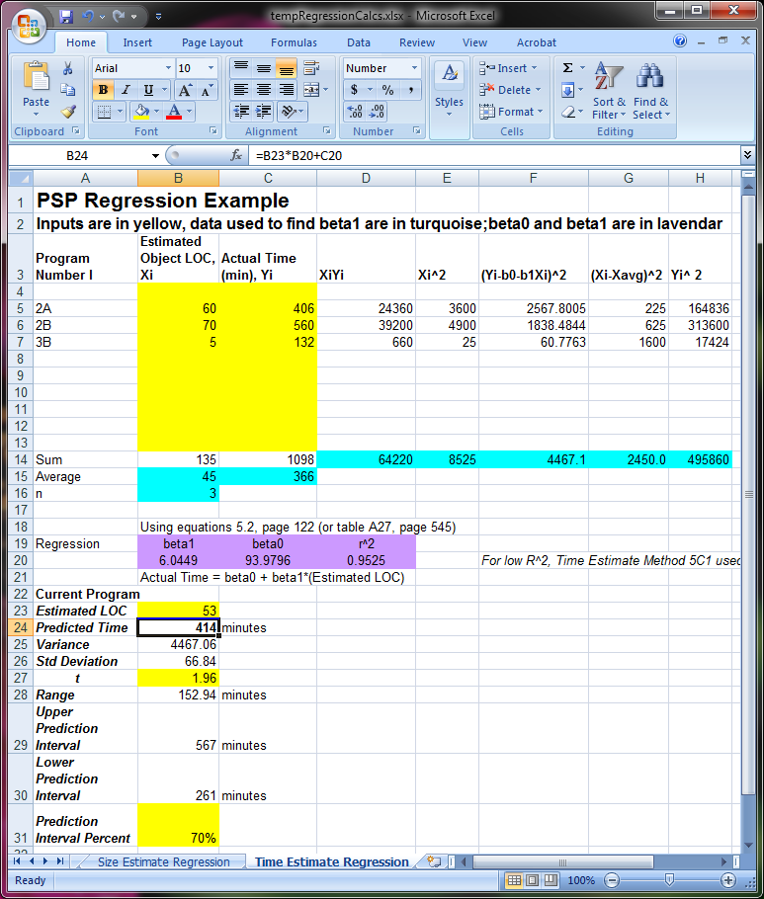
Figure 26. Regression estimates for time match spreadsheet

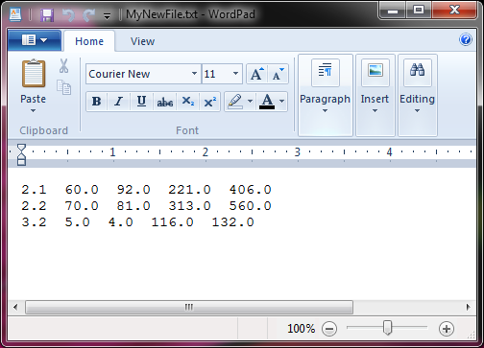
Figure 27. File creation verified in WordPad

Save As Functionality Verification

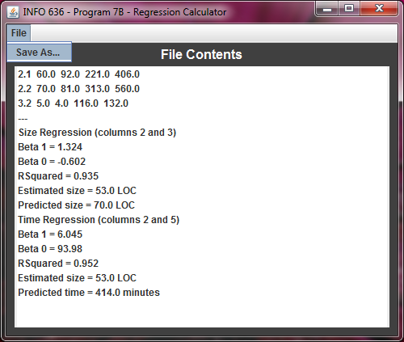
Figure 28. Save As feature selected

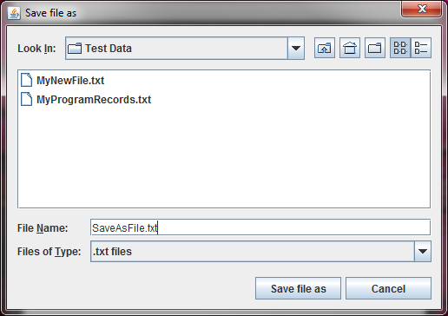
Figure 29. Data saved as SaveAsFile.txt

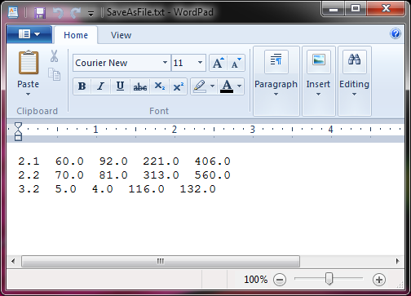
Figure 30. Saved As data displayed in Wordpad

Table 1. Input for the test cases
Program Number | Estimated (N) LOC | Actual (N) LOC | Estimated Time  (min) | Actual Time  (min)
1.2 (1B) | 200 | 157 | 300 | 186
2.1 (2A) | 60 | 92 | 221 | 406
2.2 (2B) | 70 | 81 | 313 | 560
3.2 (3B) | 5 | 4 | 116 | 132
4.2 (4B) | 53 | 43 | 175 | 195
5.2 (5B) | 39 | 57 | 105 | 179
6.2 (6B) | 44 | 162 | 240 | 196

Table C16: Time Recording Log

Student |  | Greg Vannoni |  |  |  |  | Date | 3/12/10
Instructor |  | Glenn Booker |  |  |  |  | Program # | 7B
Date | Start | Stop | Interruption  Time | Delta  Time | Phase | Comments
3/12 | 5:00p | 5:10p | 0 | 10m | PLANNING | Most of the focus is on the regression calculations needed for this program
3/12 | 5:11p | 5:21p | 0 | 10m | DESIGN
3/12 | 5:22p | 5:25p | 0 | 3m | DESIGN REVIEW | Found no problems
3/12 | 5:26p | 6:30p | 10m | 46m | CODE | Snack time, code complete
3/12 | 6:31p | 6:41p | 0 | 10m | CODE REVIEW | Found a possible rounding problem
3/12 | 6:42p | 6:47p | 0 | 5m | CODE | Fix from code review
3/12 | 6:48p | 6:49p | 0 | 1m | COMPILE | Compiled successful
3/12 | 6:50p | 7:10p | 0 | 20m | TEST | Found some defects, need to fix
3/12 | 7:11p | 7:30p | 2m | 17m | CODE | Defects corrected
3/12 | 7:31p | 7:32p | 0 | 1m | COMPILE
3/12 | 7:33p | 7:38p | 0 | 5m | TEST | Verified defects removed, movie time
3/13 | 10:00a | 11:05a | 5m | 60m | PM | Started the last PM phase of this class!
3/13 | 2:00p | 2:30p | 0m | 30m | PM | All done with PM!

Table C18 Defect Recording Log
Defect Types
10 Documentation 60 Checking
20 Syntax 70 Data
30 Build, Package 80 Function
40 Assignment 90 System
50 Interface 100 Environment
Student |  |  |  | Greg Vannoni |  |  |  |  |  |  |  | Date |  | 3/12/10
Instructor |  |  |  | Glenn Booker |  |  |  |  |  |  |  | Program # |  | 7B
Date |  | Number |  |  |  | Type |  | Inject |  | Remove |  |  | Fix Time |  | Fix Defect
3/12 |  | 1 |  |  |  | 40 |  | design |  | code |  |  | 7
 |  |  | Didn't divide by 1.0 (just 1) which caused my double to be cast to an integer and
was throwing my range calculation off by about 30.
Date |  | Number |  |  |  | Type |  | Inject |  | Remove |  |  | Fix Time |  | Fix Defect
3/12 |  | 2 |  |  |  | 80 |  | code |  | code review |  |  | 5
 |  |  | Was rounding to 3 decimal places, but it was throwing off my calculations that used
beta values by more than I expected. Changed the round to go out to 5 decimal places
Date |  | Number |  |  |  | Type |  | Inject |  | Remove |  |  | Fix Time |  | Fix Defect
3/12 |  | 3 |  |  |  | 60 |  | code |  | test |  |  | 10
Description: |  |  | In an attempt to not save the regression data to the file (and save only doubles),
my modified setFileContentsWithList function wasn't checking for doubles correctly so nothing
was being saved to the file because the program thought everything wasn't a double.
Date |  | Number |  |  |  | Type |  | Inject |  | Remove |  |  | Fix Time |  | Fix Defect
3/12 |  | 4 |  |  |  | 50 |  | code |  | test |  |  | 2
Description: |  |  | Found a bug in the modify functionality that wouldn't repaint the screen after
you were done modifying. Added an explicit call to repaint() in initializeAndDisplayWithPrompt()
Date |  | Number |  |  |  | Type |  | Inject |  | Remove |  |  | Fix Time |  | Fix Defect
3/12 |  | 5 |  |  |  | 90 |  | code |  | test |  |  | 2
Description: |  |  | Noticed that when I use the Save As functionality, I can't open the file until I close
the program. Had to add a close() operation to displaySaveAsDialog()
Date |  | Number |  |  |  | Type |  | Inject |  | Remove |  |  | Fix Time |  | Fix Defect
Description:
Date |  | Number |  |  |  | Type |  | Inject |  | Remove |  |  | Fix Time |  | Fix Defect
Description:

Table C27 Process Improvement Proposal (PIP)

Student | Greg Vannoni |  | Date | 3/12/10
Instructor | Glenn Booker |  | Program # | 7B
Process | PSP2 | Elements

PIP Number
 |  | Problem Description
1 |  | Some post-mortem things can be started during the planning phase, this
 |  | uses a lot of my time after development, but I'd rather spend it upfront.
PROPOSAL
PIP # |  | Proposal Description
1 |  | Before I start programming, during the planning phase, I can work on
 |  | the assignment table (usually on the first page), portions of the physical
 |  | & logical LOC results can be prepped, Table C37 can almost be
 |  | completed, table C39 should be completed (except actuals), and C55
 |  | should be pre-populated with To Date column information so it's easier
 |  | to perform calculations once actual data is collected. I should also
 |  | populate/modify all of the headers for all of the forms during the planning
 |  | phase.
Notes and Comments:
 |  | This program had more defects than usual. The first two were from some
 |  | mathematical issues with programming. One was caught upfront because
 |  | it's caught me so many times in my past (1.0 versus 1 when dividing).
 |  | Because this was the most calculation-centric application any rounding
 |  | errors would have hurt the final calculations in the end so I made sure to
 |  | check this although it wasn't specifically on the code review checklist.

Table C37 Test Report Template

Student | Greg Vannoni | Date | 3/12/10
Instructor | Glenn Booker | Program # | 7B

Test Name/Number | Test Case #01 - Read functionality
Test Objective | Determine if there has been regression to Read functionality and determine if error checking is performed on the selected file
Test Description | This function has not changed since Program 3B, ensure
 | ensure that the user can still read the file like in 3B, also
 | ensure that if the user enters a file that doesn't exist, they
 | are given an error message
Test Conditions | 1. File may already exist with real numbers
 | 2. There needs to be 5 columns in this file
Expected Results | 1. File selected and displayed in JList just like in
 | Program 3B
 | 2. Non-existent file is selected, user is presented with error dialog explaining the situation and may either continue (by selecting an existing file) or terminate the program
Actual Results | Success. Program displayed file just like Program 3B.
 | When an invalid file was selected, user was presented
 | with dialog box as described in expected results.
Test Name/Number | Test Case #02 - Write functionality
Test Objective | Ensure write functionality from 3B still exists and that a warning message is displayed when the user attempts to write to a file that already exists.
Test Description | 1. Ensure that write functionality has not regressed since 3B
 | 2. Ensure that new warning dialog box is displayed
 | when a number is not properly input to system.
 | 3. Ensure that a dialog box is presented to the user when they select a file that already exists.
Test Conditions | None
Expected Results | 1. File should be written to selected directory just like 3B
 | 2. If invalid input is given, a dialog box should appear that allows the user to continue (retry) or exit the application.
 | 3. If the user selects an already existing file, a dialog box should appear which will allow the user to continue (by re-entering another non-existent file) or terminate the program
Actual Results | Success. No regression to write capability, dialog box with
 | "Ok" and "Terminate Application" are displayed when
 | invalid number (integer when asked for quantity of
 | numbers and double/real number when asked for number
 | input.
Test Name/Number | Test Case #03 - Modify functionality
Test Objective | Ensure that there has been no regression in modify functionality and that the user can only select from the options in program 3B.
Test Description | 1. Validate that no functionality has changed since 3B
 | 2. Select the "Insert" button after the "Modify" mode is selected and validate that invalid number input (for real numbers) has the Program 4B warning message to the user.
 | 3. Ensure that when the user selects a non-existent file to modify they are presented with a dialog box in which they can continue or terminate the application
 | 4. Ensure that rows are displays as full rows showing 2D support. The modify feature should allow for manipulation of complete rows, not single elements.
Test Conditions | User must select "Modify" mode to be presented with
 | modify functionality
Expected Results | 1. If the user selects the "Insert" mode, and inserts a non-real number, a warning dialog should be displayed.
 | 2. All existing 3B functionality for Accept, Accept All, Replace and Delete should exist unmodified.
 | 3. If a user selects a file that doesn't exist for modification, they should be presented with a dialog box which will allow them to continue (select another file to modify) or terminate the application.
 | 4. When selecting any button, it should treat the entire 2D row as one entity, thus the "delete" button deletes the entire row, "insert" inserts an entire row with K columns, "replace" asks to replace every K columns and accept/accept all show an entire row
Actual Results | Successful, all tests passed.
Test Name/Number | Test Case #04 - File name validity check
Test Objective | Ensure the filename a user selects is valid (per Windows filename validity checks)
Test Description | 1. If a user inputs the characters \ / : * ? " < > |, a dialog box should be displayed to inform the user of an invalid file name.
Test Conditions | Java's JFileChooser may auto-correct some filenames, however, in most cases, any filename with the invalid characters as stated above should be caught.
Expected Results | 1. If the user has any characters listed above in the filename, it should be treated as invalid alerting the user as such.
Actual Results | Successful, all tests passed.
Test Name/Number | Test Case #05 - System should ask for K items per row of input
Test Objective | Depending on the compile value of ENTRIES_PER_ROW in Main.java, the system should ask the user for the number of rows * ENTRIES_PER_ROW of numbers
Test Description | 1. If a user elects to insert 3 rows, they should be prompted for 3 * ENTRIES_PER_ROW (currently set to 5) numbers to input, or more generally userInput * ENTRIES_PER_ROW
Test Conditions | The ENTRIES_PER_ROW variable must be greater than 0
Expected Results | 1. If 3 is the number of rows to input and ENTRIES_PER_ROW is 5, then the user should be asked for 15 numbers.
Actual Results | Successful, all tests passed.
Test Name/Number | Test Case #06 - Read/Write 2D Array
Test Objective | The file should be stored and displayed as a 2D array with rows and columns of data
Test Description | 1. When performing a Save As, or write operation the file created should be in a 2D array with rows and columns of numbers.  2. When opening a file using the read option, it should be displayed in a 2D format with more than one item per row and with more than one column.
Test Conditions | A valid file must be selected for writing or reading
Expected Results | 1. File displayed as 2D array with more than one row and column  2. File saved as 2D array with more than one row and column
Actual Results | Successful, all tests passed.
Test Name/Number | Test Case #07 - Column number mismatch
Test Objective | If K (ENTRIES_PER_ROW) does not match the number of columns during a Read or Write operation, the user should be informed.
Test Description | 1. When Reading or Modifying a file, if the file does not have the same number of columns as ENTRIES_PER_ROW in Main.java, the program should exit.
Test Conditions | A valid file must be selected for reading or modification
Expected Results | 1. User is presented with error dialog explaining that the number of columns in their file does not match K (ENTIRES_PER_ROW in Main.java)
Actual Results | Successful, all tests passed.
Test Name/Number | Test Case #08 - Regression Calculations
Test Objective | Ensure regression calculations are correctly performed and displayed
Test Description | 1. After selecting Read/Write/Modify, the user shall be presented regression variables Beta1, Beta0 and R².  2. New in Program 7B, the user will be presented with the predicted size and predicted time it will take to complete the task.
Test Conditions | 1. A valid file must be selected for reading or modification (see Table 1)  2. At least 3 data points must exist (or n-2 will yield a negative or 0 result)
Expected Results | 1. After the Read/Write/Modify mode is selected, the user shall be presented with regression values Beta1, Beta0 and R².  2. After selection of Read/Write/Modify mode, the user shall be presented with an input screen to capture estimated LOC. This estimated LOC should be used along with the data from the file to calculate predicted size and predicted time.  3. The user should also be presented with the  - Estimated size / Predicted size  - Estimated size / Predicted time  - Range  - Upper prediction interval  - Lower prediction interval  - t (from table A2)
Actual Results | Successful, all tests passed, regression calculations shown for each mode and shown in screenshots displayed in this report.

Table C39 Size Estimating Template
SEE SPREADSHEET(7BVannoniEstimations.xls) FOR CALCULATIONS

Table C47 Task Planning Template

Student | Greg Vannoni | Date | 3/12/10
Project | 7B | Instructor | Booker

Task |  | Plan |  |  |  |  | Actual
# | Name | Mins | Planned Value | Cumulative  Mins | Cumulative Planned  Value | Date | Date | Earned Value | Cumulative Earned Value
1 | Planning | 9 | 2.79% | 9 | 2.79% | 3/12 | 3/12 | 2.79% | 2.79%
2 | Design | 20 | 6.19% | 29 | 8.98% | 3/12 | 3/12 | 6.19% | 8.98%
3 | Design Review | 3 | 0.93% | 32 | 9.91% | 3/12 | 3/12 | 0.93% | 9.91%
4 | Code | 116 | 35.91% | 148 | 45.82% | 3/12 | 3/12 | 35.91% | 45.82%
5 | Code Review | 3 | 0.93% | 151 | 46.75% | 3/12 | 3/12 | 0.93% | 46.75%
6 | Compile | 1 | 0.31% | 152 | 47.06% | 3/12 | 3/12 | 0.31% | 47.06%
7 | Test | 32 | 9.91% | 184 | 56.97% | 3/12 | 3/12 | 9.91% | 56.97%
8 | Post-Mortem | 139 | 43.03% | 323 | 100% | 3/13 | 3/13 | 43.03% | 100%
Totals |  | 323 | 100%

Table C49 Schedule Planning Template

Student | Greg Vannoni | Date | 3/12/10
Project | 7B | Instructor | Booker

 |  | Plan |  |  | Actual
Day | Date | Direct | Cumulative | Cumulative | Direct | Cumulative | Cumulative | Adjusted
No. |  | Mins | Mins | Planned Value | Mins | Mins | Earned Value | Earned Value
1 | 3/12 | 184 | 184 | 56.97% | 128 | 128 | 56.97% | -
2 | 3/13 | 139 | 323 | 100% | 90 | 218 | 100% | -

Table C55 PSP2 Project Plan Summary

Student | Greg Vannoni | Date | 3/12/10
Program |  | Program # | 7B
Instructor | Glenn Booker | Language | Java

Summary | Plan |  |  |  | Actual |  |  |  | To Date
LOC/Hour | 86/(323/60) = 15.98 |  |  |  | 96/(218/60) = 26.4 |  |  |  | 33.5+26.4/2=  29.95
Planned Time | 323 |  |  |  |  |  |  |  | 864
Actual Time |  |  |  |  | 218 |  |  |  | 788
CPI(Cost-Performance Index) |  |  |  |  |  |  |  |  | 1.096
 |  |  |  |  |  |  |  |  | (Planned/Actual)
% Reused | 10% |  |  |  | R/N=15/96=  15.62% |  |  |  | 23.58+15.62/2=  19.6%
% New Reused (Reusable) | 0% |  |  |  | 0% |  |  |  | 14.56%
Test Defects/KLOC | 7.0 |  |  |  | 96LOC = 0.096KLOC  3/0.096=31.25 |  |  |  | 6.17+31.25/2  18.71
Total Defects/KLOC | 12.0 |  |  |  | 5/0.096 =52.08 |  |  |  | 12.34+52.08/2  32.21
Yield % | 50% |  |  |  | 60% |  |  |  | 50% + 60%/2  55%
Program Size (LOC): | Plan |  |  |  | Actual |  |  |  | To Date
Base(B) | 494 |  |  |  | 494
 | (Measured) |  |  |  | (Measured)
Deleted (D) | 5 |  |  |  | 3
 | (Estimated) |  |  |  | (Counted)
Modified (M) | 15 |  |  |  | 29
 | (Estimated) |  |  |  | (Counted)
Added (A) | 71 |  |  |  | 67
 | (N-M) |  |  |  | (T-B+D-R)
Reused (R) | 16 |  |  |  | 15 |  |  |  | 52
 | (Estimated) |  |  |  | (Counted)
Total New & Changed (N) | 86 |  |  |  | 96 |  |  |  | 545
 | (Estimated) |  |  |  | (A+M)
Total LOC (T) | 543 |  |  |  | 573 |  |  |  | 2327
 | (N+B-M-D+R) |  |  |  | (Measured)
Total New Reused (Reusable) | 0 |  |  |  | 0 |  |  |  | 77
Upper Prediction Interval (70%) | 68
Lower Prediction Interval (70%) | 19.5
Time in Phase (min.) | Plan |  | Actual |  |  |  | To Date |  |  |  | To Date %
Planning | 9 |  | 10 |  |  |  | 59 |  |  |  | 2.92%
Design | 20 |  | 10 |  |  |  | 119 |  |  |  | 5.90%
Design review | 3 |  | 3 |  |  |  | 11 |  |  |  | 0.54%
Code | 116 |  | 68 |  |  |  | 720 |  |  |  | 35.69%
Code review | 3 |  | 10 |  |  |  | 27 |  |  |  | 1.34%
Compile | 1 |  | 2 |  |  |  | 14 |  |  |  | 0.69%
Test | 32 |  | 25 |  |  |  | 200 |  |  |  | 9.91%
Postmortem | 139 |  | 90 |  |  |  | 867 |  |  |  | 42.98%
Total | 323 |  | 218 |  |  |  | 2017 |  |  |  | 100%
Total Time UPI (70%) | 475
Total Time LPI (70%) | 172

Table C55 PSP2 Project Plan Summary (continued)

Student | Greg Vannoni | Date | 3/12/10
Program |  | Program # | 7B
Instructor | Glenn Booker | Language | Java

Defects Injected | Plan |  | Actual |  |  |  | To Date |  |  |  | To Date %
Planning | 0 |  | 0 |  |  |  | 5 |  |  |  | 21.74%
Design | 1 |  | 1 |  |  |  | 5 |  |  |  | 21.74%
Design review | 0 |  | 0 |  |  |  | 0 |  |  |  | 0
Code | 2 |  | 4 |  |  |  | 13 |  |  |  | 56.5%
Code review | 0 |  | 0 |  |  |  | 0 |  |  |  | 0
Compile | 0 |  | 0 |  |  |  | 0 |  |  |  | 0
Test | 0 |  | 0 |  |  |  | 0 |  |  |  | 0
Total Development | 3 |  | 5 |  |  |  | 23 |  |  |  | 100%
Defects Removed | Plan |  | Actual |  |  |  | To Date |  |  |  | To Date %
Planning | 0 |  | 0 |  |  |  | 0 |  |  |  | 0
Design | 0 |  | 0 |  |  |  | 1 |  |  |  | 4.35%
Design review | 0 |  | 0 |  |  |  | 1 |  |  |  | 4.35%
Code | 0 |  | 1 |  |  |  | 5 |  |  |  | 21.74%
Code review | 2 |  | 1 |  |  |  | 1 |  |  |  | 4.35%
Compile | 0 |  | 0 |  |  |  | 0 |  |  |  | 0
Test | 1 |  | 3 |  |  |  | 15 |  |  |  | 65.22%
Total Development | 3 |  | 5 |  |  |  | 23 |  |  |  | 100%
After Development | 0 |  | 0 |  |  |  | 0
Defect Removal Efficiency | Plan |  |  |  | Actual |  |  |  | To Date
Defects/Hour - Design review | 0 |  |  |  | 0 |  |  |  | 0.31
Defects/Hour - Code review | 2/(323/60) = 0.37 |  |  |  | 1/(218/60)=0.275 |  |  |  | 0.275
Defects/Hour - Compile | 0 |  |  |  | 0 |  |  |  | 0
Defects/Hour - Test | 1/(323/60) = 0.18 |  |  |  | 3/(218/60)=0.826 |  |  |  | 0.31+0.826/2=  0.568
DRL(DLDR/UT) | 0 |  |  |  | 0 |  |  |  | 1
DRL(CodeReview/UT) | 0.37/0.18= 2.05 |  |  |  | 0.275/0.826=0.33 |  |  |  | 0.33
DRL(Compile/UT) | 0 |  |  |  | 0 |  |  |  | 0

Detail-level-design reviews = DLDR
Table C57 Java PSP2 Design Review Checklist

PROGRAM NAME AND #: Program 7B
Purpose | To guide you in conducting an effective design review
General | As you complete each review step, check that item in the box to the right.  Complete the checklist for one program unit before you start to review the next.
Complete | Ensure that the requirements, specifications, and high-level design are completely covered by the design:  - all specified outputs are produced  - all needed inputs are furnished  - all variables are initialized | x
Logic | Verify that all loops are properly initiated, incremented, and terminated | x
Special Cases | Check all special cases:  - empty, full, minimum, maximum, negative, zero  - Exceptions - NullPointerException and NumberFormatException specifically  - ensure "impossible" conditions are absolutely impossible  - handle all incorrect input conditions | x
Functional use | Verify that all functions, procedures, or objects are fully understood and properly used  Ensure the proper data structures are used | x
Names | Verify that:  - all special names and types are clear or specifically defined  - the scopes of all variables and parameters are self-evident or defined  - all named objects are used within their declared scopes  - variable names are of correct syntax for the language  - GUI windows use correct objects | x
Standards | Review the design for conformance to all applicable design standards | x

Table C58 Java Code Review Checklist

PROGRAM NAME AND #: Program 7B
Purpose | To guide you in conducting an effective code review.
General | As you complete each review step, check that item in the box to the right.  Complete the checklist for one program unit before you start to review the next.
Complete | Verify that the code covers all the design. | x
Initialization | Check variable and parameter initialization:  - at program initiation  - at start of every loop  - at method entry | x
Calls | Check function call formats:  - parameters | x
Assignment | - Verify declarations are valid  - Ensure variable names make sense and are valid  - Ensure data structures are proper for returned values  - Ensure data structures are valid for use in loops | x
Interface | Ensure lists are inside bounds | x
Checking | Verify that try/catch blocks are used for any code that can thrown an exception  Verify that null checking is performed for any object that can be null | x
Data | - Verify proper data types are used for array structures  - Verify correct data is read and written from disk  - Verify test data is validated | x
Names | Check name spelling and use:  - is it consistent?  - is it within declared scope? | x
Output Format | Check the output format:  - line stepping is proper  - spacing is proper | x
{} Pairs | Ensure that the {} are proper and matched | x
Logic | Verify the proper use of ==, =, ||, and so on.  Check every logic function for proper ().  Verify that if/else statements are in the proper order and are valid | x
Line by Line Check | Check every LOC for  - instruction syntax and  - proper punctuation. | x
Standards | Ensure that the code conforms to the coding standards. | x
File Open and Close | Verify that all files are  - properly declared,  - opened, flushed, and closed. | x

